SSH with VS Code

# Install VS Code and Remote - SSH extension (optional)

This step is optional but if you are familiar with VS Code or want a richer editor experience than a bash editor (vim) can offer the combination of VS Code with the remote ssh extension can offer this.

1. Install VS Code if you do not already have it installed.

<https://code.visualstudio.com/>

1. Install an OpenSSH compatible SSH client (PuTTY is not supported).

<https://code.visualstudio.com/docs/remote/troubleshooting#_installing-a-supported-ssh-client>

1. Open VS Code
2. If you do not already have the Remote - SSH extension installed, you can search for "remote ssh" in the Extensions view (Ctrl + Shift + X)
3. When asked during the lab to ssh to the build agent choose the Remote-SSH: Connect to Host command and connect to the host by entering connection information for your VM in the following format: user@hostname.

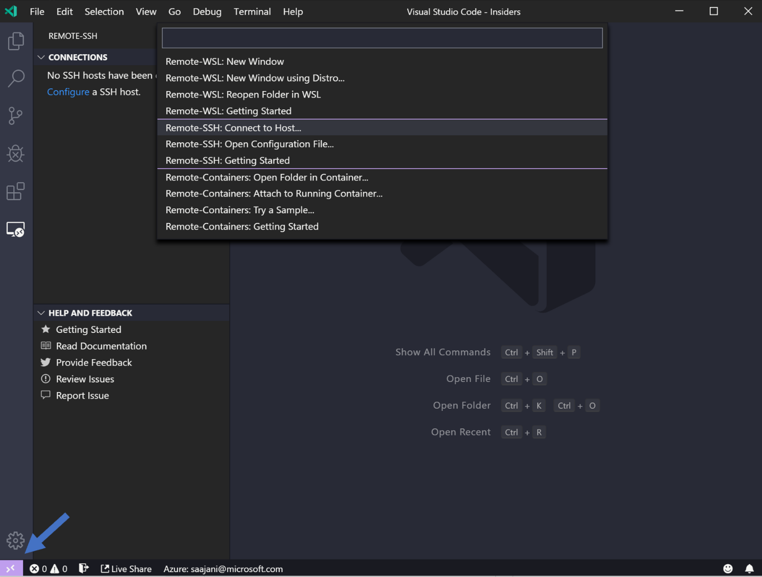

1. Set the user and hostname in the connection information text box.

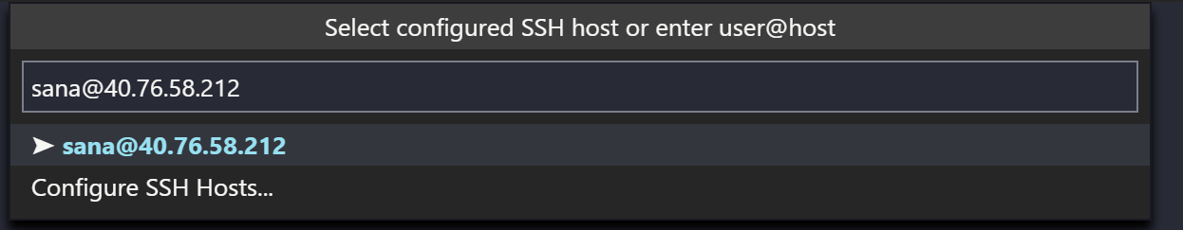

1. VS Code will now open a new window (instance). You'll then see a notification that the "VS Code Server" is initializing on the SSH Host. Once the VS Code Server is installed on the remote host, it can run extensions and talk to your local instance of VS Code.

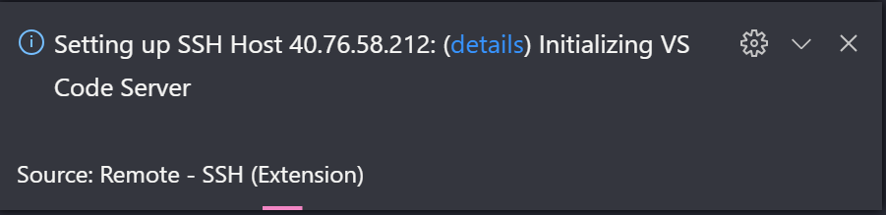

1. You will know you're connected to your VM by looking at the indicator in the Status bar. Now it shows the hostname of our VM!

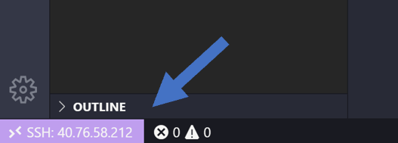

1. Once you are connected to the build agent, you can interact with files and open folders on the remote machine. If you open the integrated terminal, you will see you are working inside a bash shell.